FROM ROADS TO STREETS
Urban Regeneration for Street Conviviality – The Case of Suburbs of Ljubljana

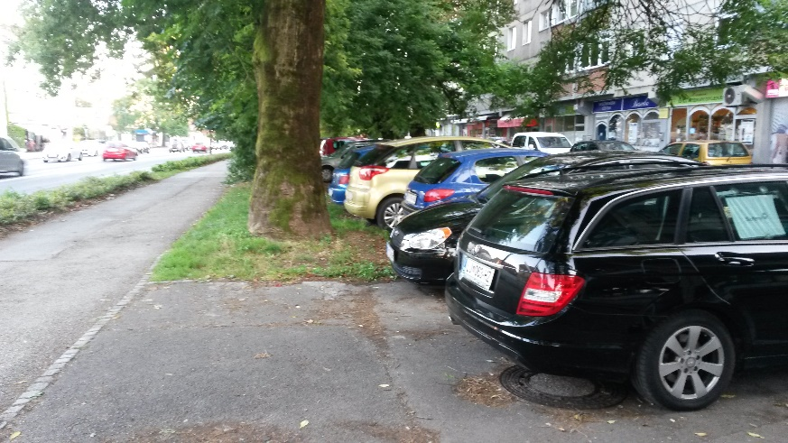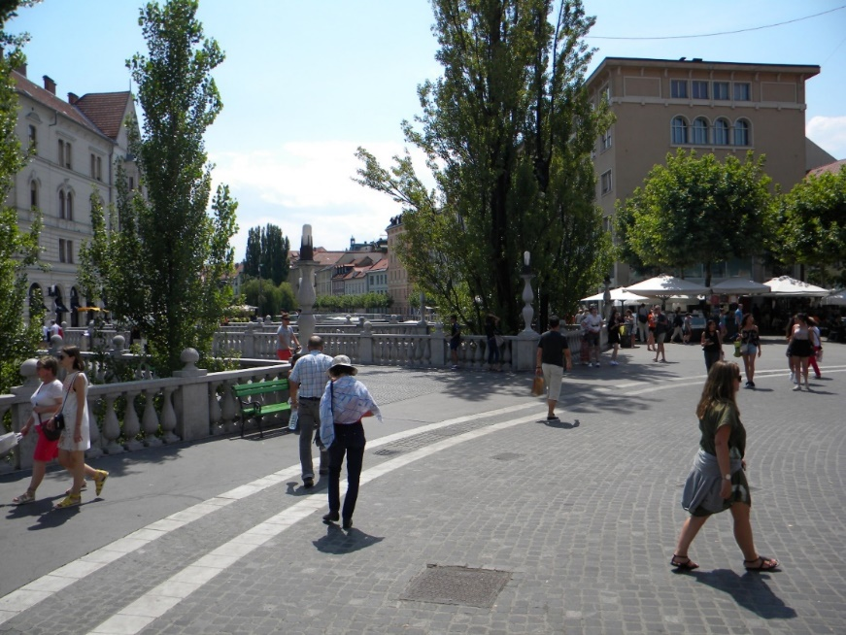

2018 INTERNATIONAL WEEK, Ljubljana, Slovenia, Jan. 29th – Feb. 2nd

Hosted by the Faculty of Architecture of the University of Ljubljana (FA) in collaboration with the Urban Planning Institute of the Republic of Slovenia (UIRS) and the Slovenian Ministry of the Environment and Spatial Planning (MOP)

Participating Universities:

HAMBURG, Department of Urban Planning, HafenCity University
LJUBLJANA, Department of Urban Planning, Faculty of Architecture, University of Ljubljana
MALMÖ, Department of Urban Studies, Malmö University
MILAN, Dipartimento di Architettura e Studi Urbani, Politecnico di Milano
PARIS, Paris School of Planning, Université Paris Est Créteil

Venue:
University of Ljubljana, Faculty of Architecture, Zoisova 12, 1000 Ljubljana, Fabianijeva predavalnica Lecture room (historic wing, ground floor)

Preliminary Programme:

DAY 1 /January 29/2018

9:00 - 9:15 Introduction
Assoc. Prof. Dr. Matej Blenkuš, Dean, Faculty of architecture, University of Ljubljana
Dr. Igor Bizjak, Director, Urban Planning Institute of the Republic of Slovenia (UIRS)
Barbara Radovan, Director General, Spatial Planning, Construction and Housing Directorate, Ministry of the Environment and Spatial Planning of RS
Assoc. Prof. Dr. Alenka Fikfak, Head of Urbanism, Faculty of architecture, University of Ljubljana
9:15 – 11:00 Theoretical insights 1
Paul Lecroart, Planning Agency for the Paris Region (IAU)
Public Space & Traffic Calming Strategies in Large Cities
Assoc. Prof. Antonio Longo, Politecnico di Milano
Urban design and public space, an interactive approach: Milan as example

Senior Lecturer, Jesper Magnusson, Department of Urban Studies, Malmö University
The street as public domain – a question of material agency?

11:00 – 11:30 Coffee break
11:30 – 13:00 Introduction to the case of Ljubljana

Prof. Janez Koželj, vice-mayor, Municipality of Ljubljana, UL, Faculty of architecture
Reinventing public spaces in Ljubljana
Prof. mag. Peter Gabrijelčič, UL, Faculty of architecture
Shared spaces as generators of public space

Dr. Breda Mihelič, emeritus member of Urban Planning Institute of RS (UIRS)
The context of the city – main development phases of Ljubljana

Dr. Luka Mladenovič, Urban Planning Institute of RS (UIRS)
Mobility policies for improved quality of urban life

13:30 – 15:00 Lunch time
16:00 – 18:00 Visit of the case study areas
Group 1 Litostrojsko naselje, Group 2 Ruski car, Group 3 Savsko naselje
18:30 – 19:30 Organisation of group work
20.00 – Evening event in FA bar

DAY 2 /January 30/2018

9:00 – 11:00 Theoretical insights 2
Dr. Pedro Gomes, Paris School of Planning
What can we learn from the organizational aspects of public space policies? The Parisian Case

Assoc. Prof. Dr. Valeria Fedeli, Politecnico di Milano
Insights on the production of new public at the regional-metropolitan scale

Assoc. Prof. Dr. Hoai Anh Tran, Department for Urban studies, Malmö University
The Aesthetisation and thematisation of public spaces

Assist. Dr. Matej Nikšič, Urban Planning Institute of RS (UIRS)
Urban walkability as a measure of a just city – the prospects of co-designed local public spaces

11:00 – 11:30 Coffee break
11:30 – 13:00 In-depth introduction to case studies
Litostrojsko naselje / presentation by tutors
Ruski car/ presentation by tutors
Savsko naselje/ presentation by tutors
13:00 – 14:00 Lunch time
14:00 – Studio 1
Working in groups – analyses, possible revisit of the sites
20:00 – Evening event: Communicating Architecture
Assist. Prof. Dr. Boštjan Bugarič: Online Plečnik Walk

DAY 3 /January 31/2018

9:00 – 10:00

Assist. Prof. Dr. Luka Skansi, University of Rijeka, Faculty of Humanities and Social Sciences
Conceptual approaches to housing estates in times of 1960’s and 1970’s Ljubljana

10:00 – 13:00 STUDIO 2
Working in groups – analyses sum up, development of rationale, development of re-design strategy, possible re-visit of the sites
13:00 – 14:00 Lunch time
14:00 – STUDIO 2
Continuation of Studio work & Feedback from tutors
20.00 – Evening event GUIDED TOUR – LJUBLJANA CITY CENTER
Assist. Prof. Dr. Boštjan Bugarič: Markets; Identity of a City

DAY 4 /February 1/ 2018

9:00 – 13:00 STUDIO 3
Working in groups – development and finalisation of re-design strategy
13:00 – 14:00 Lunch time
14:00 – STUDIO 3
Continuation of Studio work & Feedback from tutors
20.00 – Evening event
Assist. Prof. Dr. Boštjan Bugarič: Plečnik, the city and me (night walk

DAY 5 /February 2/ 2018

9:00 – 10:00 Final presentations and assessment – exhibition
10.00-13.00 Presentations of groups’ work
14:00 – CONCLUSIONS

Lectures’ Summaries:

Paul Lecroart, Planning Agency for the Paris Region (IAU)
Title of Presentation: Public Space & Traffic Calming Strategies in Large Cities
The lecture will present the historical background about the way we think cars and cities mainly referring to Europe and the USA from 1960 onwards. Various case studies from North America, Asia and Europe will address the issue of turning the urban highways to boulevards in the process of rethinking the cities. On the example of the Paris Region and other cities, traffic calming and shared space approaches will be presented.

Dr. Pedro Gomes, Paris School of Planning
Title of Presentation: What can we learn from the organizational aspects of public space policies? The Parisian Case
Discourses on what makes good public spaces are broadly consensual. However, there are sometimes striking differences in design and management practices between and within cities. This presentation will show how an analysis of organizational aspects within and beyond municipal institutions can help make sense of this diversity. Focusing on the Parisian case, it will show how different logics of public space production can be linked to institutional factors; and how sometimes innovation in public space policies require new institutions to implement change.

Assoc. Prof. Dr. Hoai Anh Tran, Department for Urban studies, Malmö University
Title of Presentation: The Aesthetisation and thematisation of public spaces
The lecture focuses on how urban design is used by governments as effective tools for social exclusion. The prescriptions of creating "mixed use” and “attractive urban spaces “for all” often used to high a range of exclusionary mechanisms. Contemporary urban places are exclusively formed to meet the tastes and preferences of the middle class, and aim to provide these privileged social groups with a safe and enhanced “urban experience”, and this often means the exclusion or expulsion of other “undesired” social groups.

Senior Lecturer, Jesper Magnusson, Department of Urban Studies, Malmö University
Title of Presentation: The street as public domain – a question of material agency?
How can the street be(come) a public domain – a space for encounters and urban social life? In what way does design of urban streetscapes affect human action and interaction? By addressing these and other questions I will try to discuss the material complexity needed for making streets into spaces for vibrant and diverse urban life.
Assist. Prof. Dr. Matej Nikšič, Urban Planning Institute RS
Title of Presentation: Urban walkability as a measure of a just city – the prospects of co-designed local public spaces
The rising motorisation in cities opens new dilemmas in the field of a just city. The empirical evidence shows that there are many negative impacts of excessive levels of motorised traffic in the cities, such as decreased air quality, loosened social interactions and declined physical activity of population. On the other hand private cars still represent a mean of equal accessibility in functional and symbolic terms – taking this opportunity away may yet largely be perceived as a way to deprive someone from the opportunities. The lecture will highlight the importance of a participatory approach to introduction of the changes to local public open spaces to support urban walkability.

Dr. Luka Mladenovič, Urban Planning Institute RS
Title of Presentation: Mobility policies for improved quality of urban life
Influence of urban planning on travel habits and mobility behaviour of citizen has been underestimated for a long time in Slovenia. Trends related to growth of motorization have been explained as a result of development of society and increased accessibility of private cars. Only in the last decade cities started to actively promote alternative modes of transport, the so called sustainable mobility. Realizing that the types of neighbourhoods the residents live in and availability of different alternatives and new services has an important impact on the way the residents travel and use public space. The presentation will focus on good examples of policies and initiatives from Ljubljana and other Slovenian towns.

Assist. Prof. Dr. Luka Skansi, Architectural historian, University of Rijeka, Faculty of Humanities and Social Sciences
Title of Presentation: Conceptual approaches to housing estates in times of 1960’s and 1970’s Ljubljana
The lecture will explore some of the experiences in the planning of housing estates in Ljubljana, in the context of the Socialist Yugoslavia of the 1960’s and 1970’s. The strategies of urban planning and the spatial arrangement of architectural assembly will be presented through the analysis of the figures involved in the planning processes, the circulation of ideas and planning models and the literature of the time.

Case Study of Ljubljana – Short introduction

Welcome to Ljubljana, a mid-sized post-socialist city of about 280.000 inhabitants where the urban development of the last two decades was characterised by the high rates of motorisation. Ljubljana is the capital city of a nation and its main employment and educational hub, there are large numbers of daily commuters from a wider region entering the city by car every day. According to the statistics there are more cars then inhabitants in the city every day. Prolonged travel times and much worsened air quality are some of the major and obvious negative consequences.

Moreover, motorisation has also a major negative impact on the local life in Ljubljana. The urban open public space, including residential streets and open spaces of the neighbourhoods, are getting dominated by motorised traffic. Thus, the traditional users of local public spaces are being limited in their rights to enjoy safe and pleasant urban open space.

These situations are typical for the aged neighbourhoods built in the socialist times between 1950s and 1970s which were not designed to accommodate large numbers of cars. Built on the concept of the modernistic urban planning they often benefit from considerably large open green areas which are nowadays getting dominated by motorised traffic in general and parked vehicles in particular. Its main social function as a meeting space and space for spending a leisure time is thus getting largely reduced. Additionally, some of their urban-design advantages are critically hindered, e.g. reduction of greenery to obtain parking space, fragmentation of safe paths to schools etc.

Nowadays the population expresses a desire to reclaim the space used by cars for pedestrian use and recreational use. The aspiration for »street conviviality« clearly manifests itself in the rediscovered open-air socialising in the redesigned public open spaces of Ljubljana's city centre, namely along Ljubljanica river. A large investment programme of the last decade considerably improved the pubic open space amenities in the central part of the city. Along with a considerable reduction of the motorised traffic the improvements revived not only the street life but also boosted the local economy with new services and small businesses.

These well-planned processes do not take place in the suburban areas unfortunately. A comprehensive approach to the betterment of the public open space in the suburban housing estates is still to be developed. However, there are few examples of civil initiatives that have been self-organised in a bottom-up manner to improve local public spaces. They function in an informal way to rise the awareness of the potential of the local public spaces, by organising the events such as street markets, performances, art interventions and collaborative workshops or make temporary physical interventions to enable space's capacities to serve the needs of local inhabitants better.
The strategic urban development documents of the City of Ljubljana address the issue of the quality of public open space in suburban neighbourhoods through two main angles: the urban regeneration strategies and the sustainable mobility policies. They favour an equal use of street space by all types of users (motorized and non-motorized) by changing the traffic regulations and redesigning street surfaces to be more supportive to non-motorized users.

The aged suburban housing estates are defined as priority areas of renovation from the point of view of inadequate urban and architectural standards as they no longer meet the requirements of modern life because they are poorly equipped (lack of services, basic supply, infrastructure) or are poorly managed, the dwellings no longer fulfil the current housing standards and do not provide adequate housing conditions, do not meet the energy efficiency standards and do not provide adequate levels of fire and earthquake safety. Among such areas are some older suburbs, older residential settlements and colonies, urbanized villages, as well as some older residential neighbourhoods. As a rule, a complete or partial renewal should be carried out in these areas.

At the same time the recently upgraded mobility policies address the issues of quality of urban living, they foresee:
- prioritized sustainable mobility to reduce air pollution, noise, energy use and space consumption by providing exclusive pedestrian zones;
- priority given to safety over smooth traffic flow by introducing sidewalks and new pedestrian crossings;
- introduction of urban design solutions, such as kerb ramps, to cater for the needs of pedestrians, cyclists and vulnerable groups (children, elderly, the disabled);
- promotion of lively streets to improve the quality of urban living and social cohesiveness by supporting the attractive buildings' frontages and street furniture to encourage organized and spontaneous street activities.

While the strategic guidance is clear, currently the realization of the policies is lacking behind and no sufficient organisational structures as well as funds seem to be available. Additionally, the exchange of powers between the national and local governing bodies over the road space hinders the efficiency. Innovative approaches that will comprehensively cover different aspects of quality of urban life are needed to make the break-throughs.

The International Week will seek strategies to address the issue of motorisation of urban public open space in aged up urban areas and seek the possible alternative futures as part of urban regeneration strategies. The introductory theoretical framework will put light onto the complexity of turning a car-centred urban open space into a human-oriented one. The uses of public space and pedestrian oriented planning strategies will be closely looked at. The issues of strategic planning, regeneration policies, mobility measures, ownership issues, financial obstacles, urban justice aspects etc. will be addressed. Example from France, Sweden, Germany; Italy and international ones will be raised. The Ljubljana case would also be extensively presented. Studio work will develop alternative future scenarios for public open spaces of concrete locations in suburban Ljubljana. Each students' group will choose one type of a typical element of Ljubljana's road/street network. Each team will develop first a site analysis based on fieldwork (mainly observation of the uses of public space, street interviews, photographic surveys...) and statistical data. Based on field analyses each student team will develop its own urban design concept for the reclamation of public space in the selected area.

Proposed case study types:
A. main city avenue – the primary city artery designed for loads of motorised traffic
Leading question: How can a major city thoroughfare become a more pleasant space for non-motorised traffic?
Case studies:
1. Celovška road (links to Litostroj neighbourhood)
2. Dunajska road (links to Ruski car neighbourhood)
3. Šmartinska road (links to Savsko neighbourhood)
/these types of roads are normally in jurisdiction of a state – relation to national open space policies/

B. residential street – the anonymous local street, traditionally a stage of local life and neighbours' interactions, nowadays largely dominated by parked vehicles;
Leading question: How can local streets be turned from linear parking spaces into places of local encounters?

Case studies:
1. Litostroj neighbourhood (links to Celovška road)
2. Ruski car neighbourhood (links to Dunajska road)
3. Savsko neighbourhood (links to Šmartinska road)
/these types of streets are in jurisdiction of a local administration – relation to local open space strategies and questions of participatory/bottom-up urbanism/

Tutors from UL FA:
assist. prof. dr. Matevž Juvančič, assist. prof. Primož Hočevar, assist. dr. Špela Verovšek, assist. Aleksander Vujović, assist. Janez P. Grom, assist. Sinan Mihelčič, assist. Nejc Černigoj, Urša Kalčič, Mia Crnič and others

Critics from UL FA:
assoc. prof. dr. Alenka Fikfak, assist. prof. dr. Ilka Čerpes, prof. mag. Tadej Glažar, izr. prof. dr. Tadeja Zupančič, assist. prof. mag. Polona Filipič
and from partners insitutions and others invited

Further Reading
Participants of the International Week are adviced to review some selected articles and other materials contributed by the lecturers or affiliated partners, as listed here below.

Camilo Calderon and Lorenzo Chelleri, 2013: Social Processes in the Production of Public Spaces: Structuring Forces and Actors in the Renewal of a Deprived Neighbourhood in Barcelona, accesible at http://www.tandfonline.com/doi/abs/10.1080/13574809.2013.800449

Steven Flusty, 2001: The Banality of Interdiction: Surveillance, Control and the Displacement of Diversity, accesible at http://onlinelibrary.wiley.com/doi/10.1111/1468-2427.00335/abstract

Merle Jacob and Tomas Hellström, 2010: Public-space planning in four Nordic cities: Symbolic values in tension, accesible at https://www.sciencedirect.com/science/article/pii/S0016718510000412

Paul Lecroart, 2015: Rethinking post-carbon cities: From expressway to boulevard, accesible at http://www.iau-idf.fr/en/know-how/scope-of-activities/benchmarks/benchmarks/rethinking-post-carbon-cities.html

Paul Lecroart, 2017: Transitional and Participative Urbanism in the Paris Metropolitan Region, accesible at http://www.association-espaces.org/wp-content/uploads/2017/05/RP_Urbanisme-participatif-mag-chinois-janvier-2017-1.pdf

Gordon MacLeod and Kevin Ward, 2002: 2002: Spaces of Utopia and Dystopia: Landscaping the Contemporary City, accesible at https://www.jstor.org/stable/3554313

Jasper Magnusson, 2016: Clustering Architectures: The Role of Materialities for Emerging Collectives in the Public Domain /focus on chapter 7/, accesible at https://lup.lub.lu.se/search/publication/14219203-921a-45ad-adbc-2eac512a38ce

Matej Nikšič, 2017: Is a Walkable Place a Just Place? The Case of Ljubljana, accesible at http://www.alexandrinepress.co.uk/built-environment/public-space-and-urban-justice

R. Alan Walks, 2006: Aestheticization and the cultural contradictions of neoliberal (sub)urbanism, accesible at http://journals.sagepub.com/doi/abs/10.1191/1474474006eu369oa

Ljubljana related materials:
Breda Mihelič (ed.), 2014: Ljubljana, Portrait of a City, accesible at https://www.ljubljana.si/en/municipality/city-of-ljubljana-publications/
City of Ljubljana, web sorce: The highest number of changes in the right direction, accesible at https://www.ljubljana.si/en/ljubljana-for-you/transport-in-ljubljana/
Civitas Elan, not dated: Innovative Cities, Before and After CIVITAS, accesible at http://civitas.eu/sites/default/files/civitas_elan_final_brochure_final_0.pdf
International Week 2018 Ljubljana, Selected Neighbourhoods two-pagers

